

**JSPM’s**

**Bhivarabai Sawant Institute of Technology and Research, Wagholi, Pune-412207.**

**Department of Computer Engineering**

**WORKBOOK**

**BE COMPUTER SEM I**

**A.Y. 2020-2021**

**SUBJECT: ARTIFICIAL INTELLIGENCE AND ROBOTICS(AIR)**

**UNIT NO: 3**

**LOGIC AND REASONING**

**Completed By:**

**Student Name: A. Shiva Surya Saran**

**Roll No: 20**

**Division: BE-B**

**Syllabus Covered**

|  |  |  |
| --- | --- | --- |
| **Unit III** | |  | | --- | | Logic and Reasoning | |
| Knowledge Based Reasoning: Agents, Facets of Knowledge. Logic and Inferences : Formal Logic, Propositional and First Order Logic, Resolution in Propositional and First Order Logic, Deductive Retrieval, Backward Chaining, Second order Logic Knowledge Representation : Conceptual Dependency, Frames, Semantic nets. | |

1. **Define the following:**

**Propositional Logic:**

Propositional logic, also known as sentential logic and statement logic, is the branch of logic that studies ways of joining and/or modifying entire propositions, statements or sentences to form more complicated propositions, statements or sentences, as well as the logical relationships and properties that are derived from these methods of combining or altering statements.

**Predicate Logic:**

A predicate is an expression of one or more variables defined on some specific domain. A predicate with variables can be made a proposition by either assigning a value to the variable or by quantifying the variable.

**Backward Chaining:**

Backward-chaining is also known as a backward deduction or backward reasoning method when using an inference engine. A backward chaining algorithm is a form of reasoning, which starts with the goal and works backward, chaining through rules to find known facts that support the goal.

**Semantic networks:**

A semantic network is a graphic notation for representing knowledge in patterns of interconnected nodes.

**Knowledge Based Agents**

Knowledge-based agents are those agents who have the capability of maintaining an internal state of knowledge, reason over that knowledge, update their knowledge after observations and take actions. These agents can represent the world with some formal representation and act intelligently.

**2) The following fig. shows architecture. Name it:**

***Fig. above is for Expert System.***

**3) Write the missing term.**

1. Rule-based system architecture consists of set of rules, set of facts and inference engine.

2. Forward Chaining also called as data driven. It starts with facts, and sees what rules apply.

3. Unification is the process of finding substitutions that make different logical sentences look identical.

4. A Knowledge Representation is a set of representations of facts or information of the world.

5. Knowledge Representation is basically a formal notation to represent knowledge that allows making inference and helps to solve a problem.

**4) Differentiate between the following:**

|  |  |
| --- | --- |
| **Forward Chaining** | **Backward Chaining** |
| Forward chaining starts from known facts and applies inference rule to extract more data unit it reaches to the goal. | Backward chaining starts from the goal and works backward through inference rules to find the required facts that support the goal. |
| It is a bottom-up approach | It is a top-down approach |
| Forward chaining is known as data-driven inference technique as we reach to the goal using the available data. | Backward chaining is known as goal-driven technique as we start from the goal and divide into sub-goal to extract the facts. |
| Forward chaining reasoning applies a breadth-first search strategy. | Backward chaining reasoning applies a depth-first search strategy. |
| Forward chaining tests for all the available rules | Backward chaining only tests for few required rules. |
| Forward chaining is suitable for the planning, monitoring, control, and interpretation application. | Backward chaining is suitable for diagnostic, prescription, and debugging application. |
| Forward chaining can generate an infinite number of possible conclusions. | Backward chaining generates a finite number of possible conclusions. |
| It operates in the forward direction. | It operates in the backward direction. |
| Forward chaining is aimed for any conclusion. | Backward chaining is only aimed for the required data. |

**5) Complete the missing contents of the figure:**

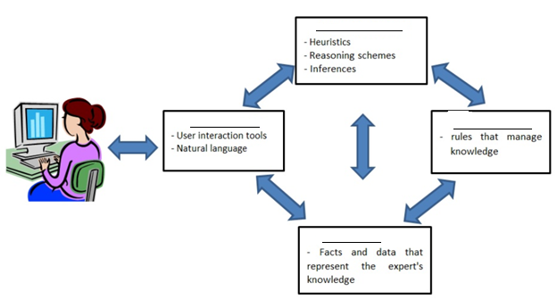

d.

c.

b.

a.__

1. *Inference Engine*
2. *Rules Library*
3. *Knowledge Base*
4. *User Interface*

**---------------------------------------EVALUATION SHEET ------------------------------**

|  |  |  |  |
| --- | --- | --- | --- |
| **Ques.no** | **Max.Marks** | **Marks Obtained** | **Remark** |
| 1 | 5 |  |  |
| 2 | 2 |  |  |
| 3 | 5 |  |  |
| 4 | 4 |  |  |
| 5 | 4 |  |  |
| **TOTAL** | **20** |  |  |

**SUBJECT INCHARGE DAC HOD**